REVIEW OF EVENTS AT THE LEE MONUMENT ON JUNE 1, 2020
The sole purpose of this Review by the Office of the Commonwealth’s Attorney is to determine whether any individual officer employed by the Richmond Police Department (“RPD”) engaged in criminal conduct during the response to the protests at either the Robert E. Lee monument (“Lee monument”) or the J.E.B. Stuart monument (“Stuart monument”) at approximately 7:30 p.m. on June 1, 2020. For the following reasons, I conclude they did not.
The Review is based upon the following evidence and information received from the Richmond Police Department (“RPD”) including:
- Internal Affairs Preliminary Investigative Report and Additional Summary;
- Incident Action Plan;
- Video and Transcript of audio from “Air 3” (law enforcement airplane);
- Emails;
- Audio and transcript of RPD radio/dispatch transmissions;
- Video from drone;
- Body worn camera (“BWC”) video from officers present at either the Lee or Stuart monuments.

STATEMENT OF EVENTS
- Following the murder of George Floyd on May 25, 2020, Richmond was the scene of peaceful protests during the daytime and violent and destructive rioting and looting during the nighttime on May 29 and 30.

- As a result of the destruction and violence, Governor Ralph Northam issued Executive Order No. 64 on May 31, 2020. The Executive Order declared a curfew in effect in the City of Richmond, beginning at 8 p.m. on May 31, 2020. Despite the Governor’s order, large crowds defied the curfew and there was more violence and rioting throughout the City on the night of May 31 and into the morning hours of June 1, 2020.

- The Lee monument and the Stuart monument are one block from each other on Monument Avenue, a distance of approximately 1/10th of a mile.

- During the evening of June 1, there were hundreds of protesters at the Stuart monument and a significantly larger crowd of protesters at the Lee monument during the same time period. Air 3 broadcast live audio and video of the activities at the Stuart monument to RPD Command and other officers. There was no Air unit that similarly observed or broadcast what was occurring at the Lee monument.

- RPD Command consisted of Chief of Police William C. Smith and members of his executive staff, none of whom were physically present at either the Lee or Stuart monuments.

- Air 3 video showed that by 7:29 p.m., two men had climbed to the top of the Stuart monument with hacksaws and were sawing at the legs of the statue’s horse. At 7:30 p.m. Air 3’s camera zoomed in to show these individuals and Air 3 broadcast “yep, we got eyes on them, they’re actively cutting, cutting at the legs.” An American flag was set on fire shortly thereafter. At 7:31 p.m. the two cutters climbed down with the help of other protesters and two other individuals threw ropes over the monument in an effort to pull down the Stuart monument.

- Initially, nine officers arrived at the Stuart monument at 7:32 p.m. and the protesters temporarily scattered. By 7:34 p.m. most of the protesters had returned to Stuart monument and a few had resumed trying to throw a rope over the top of the monument. Most of the protesters formed a rough line and faced the officers. The officers observed the scene but were greatly outnumbered by the approximately 400 protesters and did not approach them. A Mayday signal was broadcast just after 7:34 p.m.

- At 7:35 p.m. Air 3 announced, “Alright, you still have people trying to sling a rope over the monument, on the backside of where you guys (officers) can’t see…one or two males.” At 7:35:45 p.m. Air 3 broadcast that “those people (officers) on the ground are outnumbered, they need more people over there (at the Stuart monument).”

- During this same time period, a much larger crowd had gathered around the Lee monument. Hundreds of protesters were gathered on the east side of the Lee monument and were listening to speakers who are standing on the monument’s pedestal. The protesters were peaceful and no one had thrown ropes over the Lee monument or climbed to the top of the Lee monument to saw any part of it.

- Based on the information transmitted by Air 3 about what protesters were doing at the Stuart monument, an RPD Sergeant requested permission from Command to disperse the crowd by deploying “OC gas” or “chemical agents.” Oleoresin capsicum or “OC gas” is the non-lethal chemical spray that RPD officers are trained to use to disperse a crowd based upon the circumstances.

- RPD Command authorized the use of OC gas at 7:31 p.m. The first photograph below shows a snapshot of the video at the Stuart monument via Air 3 that Command was viewing seconds before the authorization was given. Neither the Sergeant nor RPD Command ever specified at which monument---Lee or Stuart---OC gas was authorized to be deployed. The evidence is clear that RPD Command believed that permission was being granted to “use gas” at the Stuart monument. It is also clear that the Sergeant requesting permission believed that permission was being granted to “use gas” at the Lee monument.

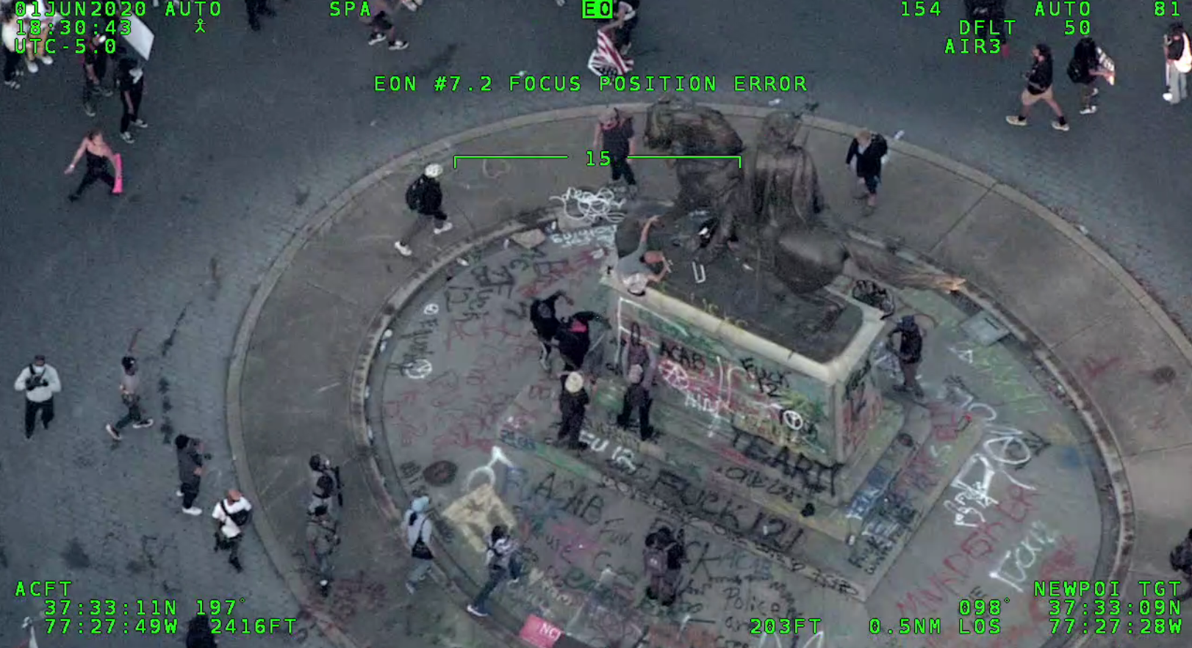

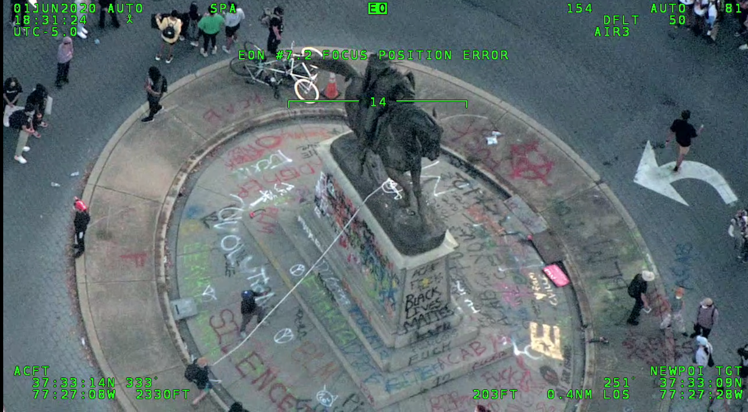

- In addition to transmissions by Air 3, there were multiple officers talking on multiple channels during the protests at the Lee and Stuart monuments. Most speakers did not identify themselves, so it was often unclear who was speaking; at which monument the speaker was located; and what the speaker was saying. In addition, coherent conversations was limited by the crowd noise and by the fact that many officers were talking through some type of helmet or mask (either an N-95 or other pandemic face mask or a gas mask). For all of these reasons, a number of conversations, or portions thereof, were unintelligible.

- During this critical four to six-minute time period, there were very few references during the police communications to a specific monument by name. The overwhelming majority of the conversations simply referred to “the monument.” This lack of clarity contributed to the overall confusion and chaos.

- Most RPD officers who arrived at the Lee monument did so because they were driving in from a staging area west of the monuments and the Lee monument was the first one they arrived at that had a large crowd of protesters.

- Given the information from Air 3 that protesters were trying to pull down “the monument” and mistakenly believing that it was the Lee monument that was being referred to, police vehicles arrived at the Lee monument shortly after 7:32 p.m. and blocked the eastbound lane of Monument Avenue near the former Lee Medical Building (“Lee Building”) at 1805 Monument Avenue. The crowd immediately became aware of their arrival and moved from the east side of the monument to the west side. The crowd formed a rough line from one side of North Allen Street to the other side and across the grounds of the monument. At this point, protesters were blocking the motor vehicle travel lanes around the Lee monument. Officers were not able to view the east side of the Lee monument and ascertain what was happening on that side of the Lee monument. Approximately 55-60 police officers formed a rough oval shape in the street near the Lee Building on the west side of the monument.

- Having received permission from Command to deploy OC gas at 7:31 p.m. and being directed to do so by the Sergeant receiving that permission, an officer who is standing in the street near the Lee Building threw an OC canister into the crowd at the Lee monument at approximately 7:35 p.m.

- Given the continued efforts at the Stuart monument to pull it down, additional officers began arriving on scene at 7:36 p.m. and OC gas was deployed at the Stuart monument shortly after 7:39 p.m.

- The authorization to deploy OC gas had nothing to do with the 8 p.m. curfew. Officers did not deploy OC gas to preempt the curfew, which had not yet gone into effect for that night. OC gas was mistakenly deployed at the Lee monument because of the dangerous conduct that was actually occurring at the Stuart monument. The primary factors that led to the deployment of OC gas at the Lee monument were:

  - the conduct of protesters at the Stuart monument that required urgent action by officers to avoid potential grave injury to the public, such as the serious injury that later occurred during a protest in Portsmouth, Virginia when a monument was pulled down;
  - the fact that the Lee monument was the first monument with a large crowd of protesters observed by officers responding from their staging area;
  - due to the line of protesters, the inability of officers who responded to the Lee monument to see whether any dangerous activity was actually taking place on the east side of the monument; and
  - the ambiguity and confusion in RPD communications in referring to the Lee and Stuart monuments.

ANAYLYSIS AND CONCLUSION
In order for any individual to be charged with committing a criminal offense, there must be evidence of both a mens rea (criminal intent) and an actus rea (criminal act). The officers who deployed OC at both the Lee and Stuart monuments did so only after receiving a lawful order and authorization to deploy OC from Command---that is, from the Chief of Police. There is no evidence that any officer violated the chain of command and deployed OC prior to receiving Chief Smith’s permission to do so. Indeed, approximately four minutes elapsed between Chief Smith’s authorization and the actual deployment of OC at the Lee monument.
It is deeply unfortunate that, given the multiple levels of miscommunication and confusion detailed above, no one in Command was able to observe the entire circumference of the Lee statue during those four minutes, realize that no one was on top of that statue or trying to pull it down, and reevaluate the situation prior to OC being deployed at the Lee monument. The lack of clear and precise communication between Air 3, Command, and the multiple supervisors and officers on the scene during a critical four to six minute time-frame led to the unnecessary use of OC spray at the Lee monument. Chief Smith made the decision to approve the use of OC spray by his employees and he was held accountable for that decision by being removed from office on June 16, 2020. There is no criminal liability or culpability for any individual officer who appropriately followed an order in the chain of command that was lawful but, with hindsight, in error.

Colette Wallace McEachin
Commonwealth’s Attorney
July 29, 2022

