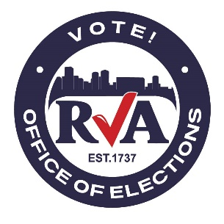

**“I VOTED” STICKER CONTEST ENTRY FORM**

__________________________ __________________________ ______

Last Name First Name Middle Initial

Address (House Number, Street, City, State, Zip Code)

(_____)______________________________ _______________________________________

Phone Number Email Address

____________________________________ ___________

School Year

* I hereby declare that I have read the Official Rules of the contest. I, and my submitted artwork, meet the guidelines outlined in the Official Rules.

____________________________________ ___________

Signature of Student Date

**Submission Deadline: May 12, 2023 by 5:00 PM**

**Please submit this entry form along with your artwork to stickercontest@rva.gov**